Project Design Phase-II Technology Stack (Architecture & Stack)

|  |  |
| --- | --- |
| Date | 13 October 2022 |
| Team ID | PNT2022TMID04292 |
| Project Name | A Novel Method for Handwritten Digit Recognition System |
| Maximum Marks | 4 Marks |

Technical Architecture for Handwritten Digit Recognition System:

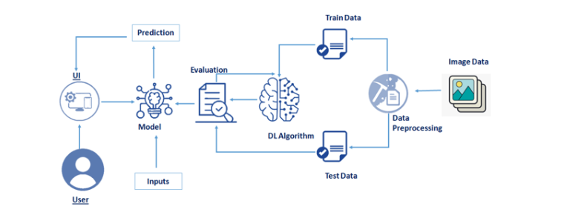

Table-1 : Components & Technologies:

|  |  |  |  |
| --- | --- | --- | --- |
| **S.No** | **Component** | **Description** | **Technology** |
| 1. | User Interface | User interacts the application using a web app | HTML, CSS, JavaScript / Angular Js / React Js etc. |
| 2. | Application Logic | Login to access the application | Java / Python |
| 5. | Database | Data Type, Configurations etc. | MySQL, NoSQL, etc. |
| 6. | Cloud Database | Database Service on Cloud | IBM DB2, IBM Cloudant etc. |
| 7. | File Storage | Storage of user files of handwritten image | IBM Block Storage or Other Storage Service or Local Filesystem |
| 10. | Machine Learning Model | Machine learning model is used to identify the handwritten image uploaded by users | Object Recognition Model, etc. |
| 11. | Infrastructure (Server / Cloud) | Application Deployment on Local System / Cloud Local Server Configuration: -  Cloud Server Configuration :- | Local, Cloud Foundry, Kubernetes, etc. |

Table-2: Application Characteristics:

|  |  |  |  |
| --- | --- | --- | --- |
| **S.No** | **Characteristics** | **Description** | **Technology** |
| 1. | Open-Source Frameworks | Used to freely access the public code | Angular JS |
| 2. | Security Implementations | Firewall is implemented | e.g. SHA-256, Encryptions, IAM Controls, OWASP etc. |

|  |  |  |  |
| --- | --- | --- | --- |
| **S.No** | **Characteristics** | **Description** | **Technology** |
| 4. | Availability | The application will be available in all regions | Distributed servers |
| 5. | Performance | Higher efficiency of performance. The application can give response to requests within 5 sec. | - |

References:

<https://c4model.com/>

<https://www.ibm.com/cloud/architecture>

<https://aws.amazon.com/architecture>

<https://medium.com/the-internal-startup/how-to-draw-useful-technical-architecture-diagrams-2d20c9fda90d>